PRACTICAL 1

Aim: Configure Cisco Routers for Syslog, NTP, and SSH Operations

1. Configure OSPF MD5 Authentication
2. Configure NTP
3. Configure Routers to Log Messages to the Syslog Server
4. Configure R3 to Support SSH Connections

Step 1: Configure the topology

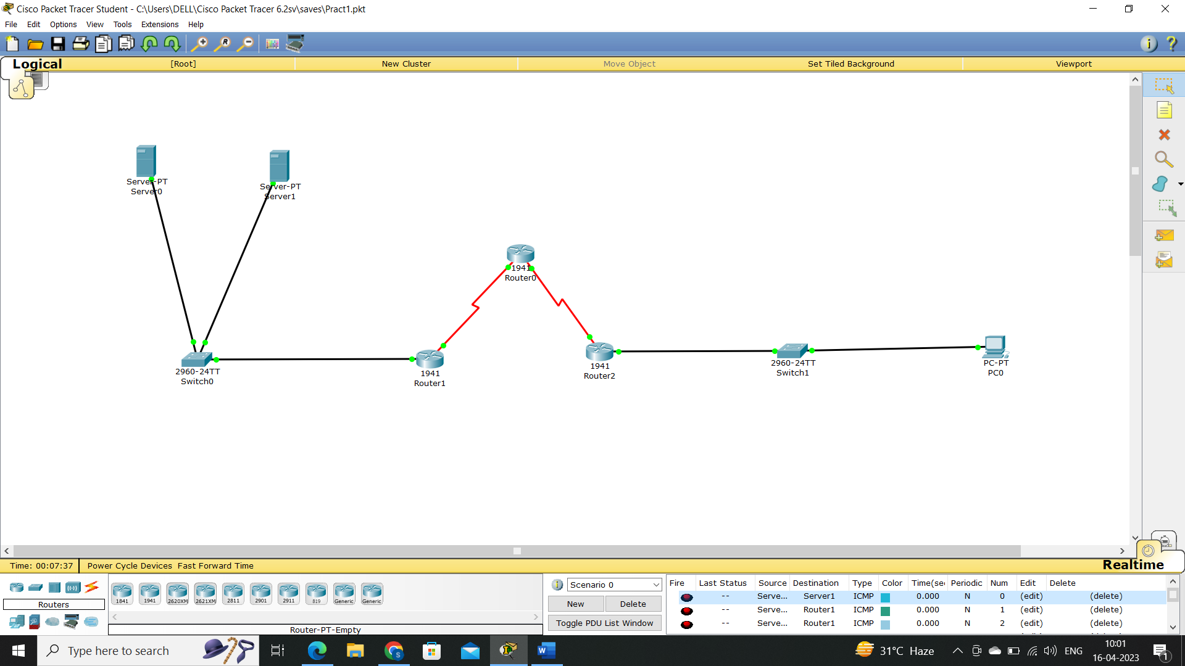

Step 2: Perform OSPF for Routers

CLI Commands for Router0

Router > enable

Router # Configure terminal

Router (config) # router ospf1

Router (config-router) # network 192.168.1.0 0.255.255.255 area 1

Router (config-router) # network 192.168.2.0 0.255.255.255 area 1

CLI Commands for Router 1

Router > enable

Router # Configure terminal

Router (config) # router ospf1

Router (config-router) # network 192.168.2.0 0.255.255.255 area 1

Router (config-router) # network 192.168.3.0 0.255.255.255 area 1

Step 3: Check the connectivity using ping command

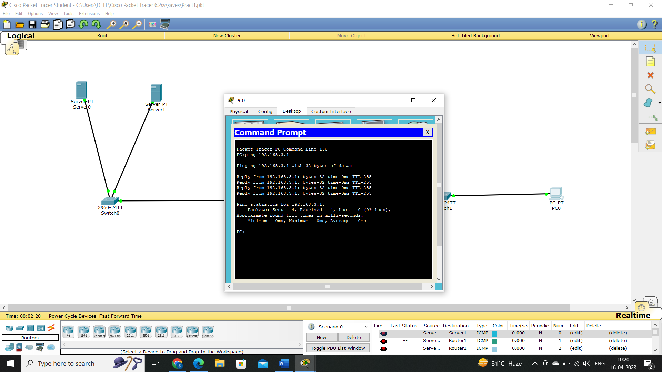

Step 4: MD5 Authentication

Write Following CLI Commands in both routers

Router > enable

Router # Configure terminal

Router (Config) # interface gigabitEthernet 0/1

Router (config -if) # ip ospf authentication message-digest

Router (config-if) # ip ospf message-digest-key 1 md5 sana

Step 5: To verify MD5 authentication

Router # show ip ospf interface gigabitEthernet 0/1

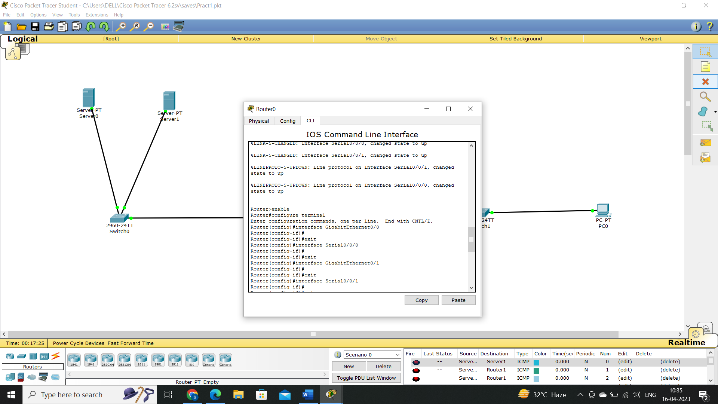

C. SYSLOG

Step 8: Go to syslog server and turn on SYSLOG services

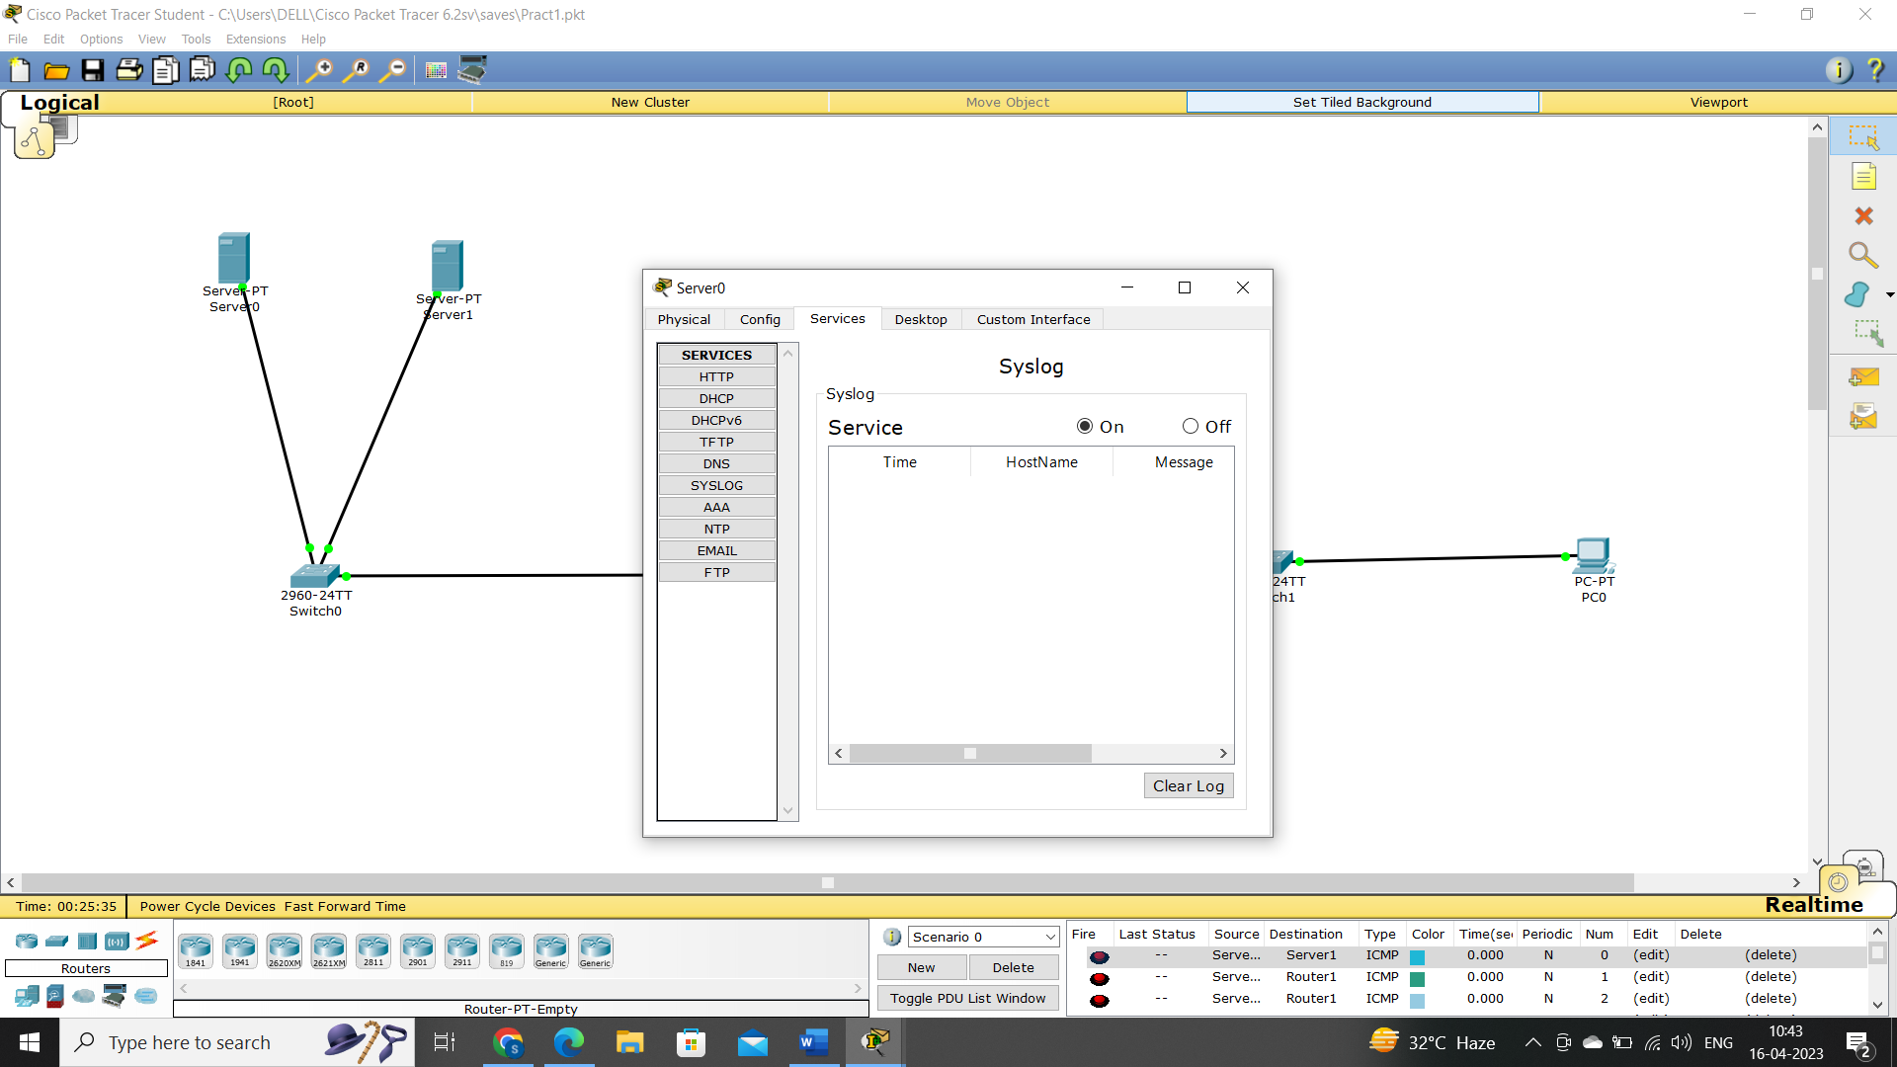

Step 9: Write following commands to the CLI of both routers

Router # conf t

Router (config) # logging 192.168.1.2

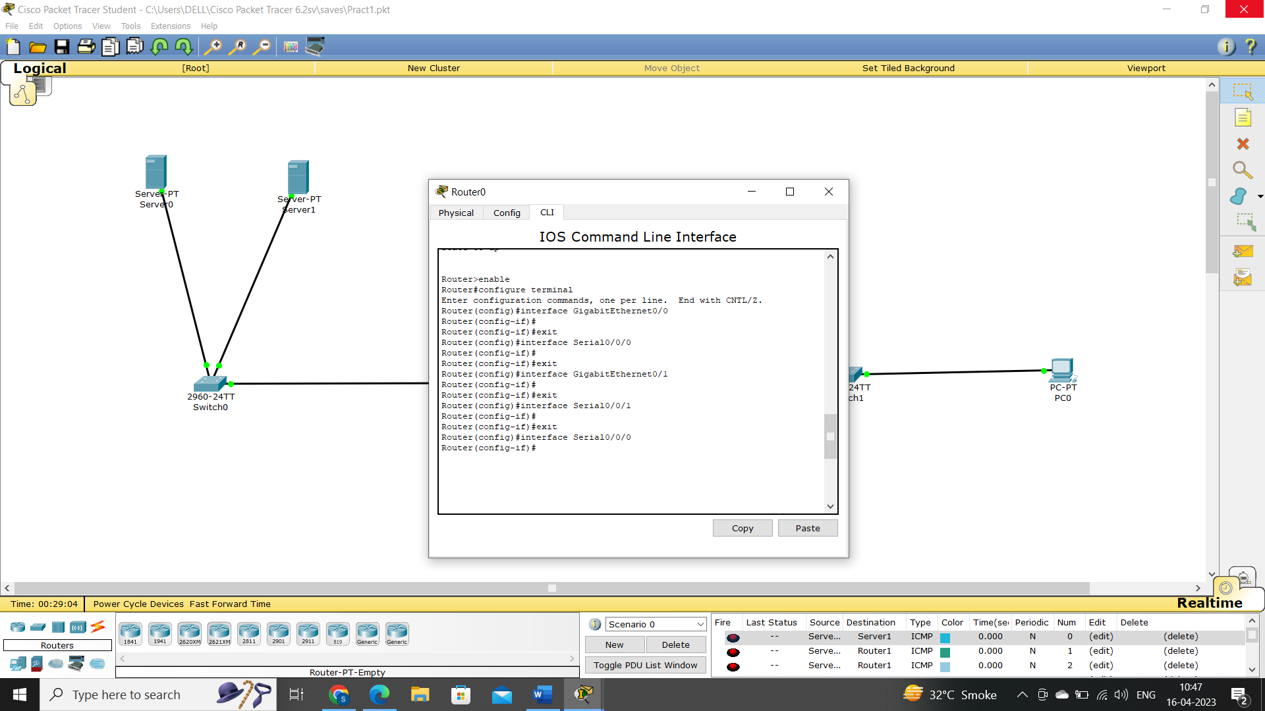

D. SSH Protocol

Step 10 : Write following commands to the CLI of Router

Router # conf t

Router (config) # ip domain-name sana.com

Router (config) # hostname R1

R1 (config) # crypto key generate rsa

How many bits in the modulus [512]:512

R1 (config) # line vty 0 4

R1 (config-line) # transport input ssh

R1 (config-line) # login local

R1 (config) # username admin privilege 15 password roots

R1 (config) # exit

Step 11: To verify ssh

Go to any pc`s command prompt and type

> Ssh -1 admin 192.168.3.1 and provide password

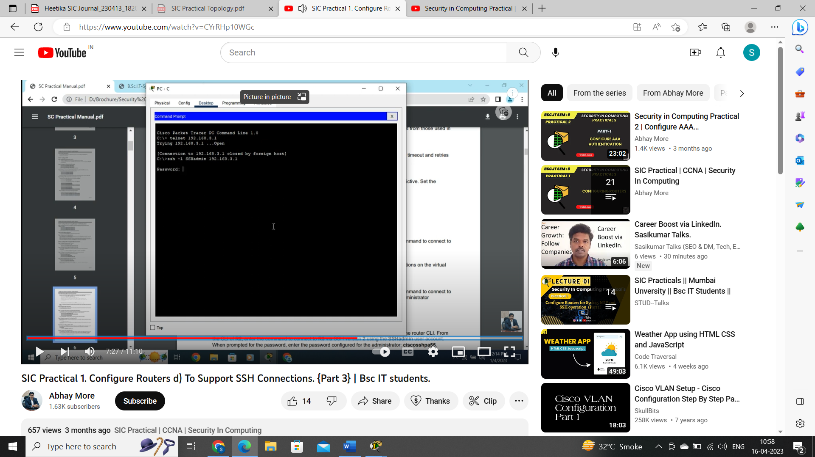

PRACTICAL 2

Aim: Configure AAA Authentication on Cisco Routers

1. Configure a local user account on R1 and configure authenticate on the console and vty lines using local AAA.
2. Verify local AAA authentication from the R1 console and the PC-A client.

Step 1: Configure the topology

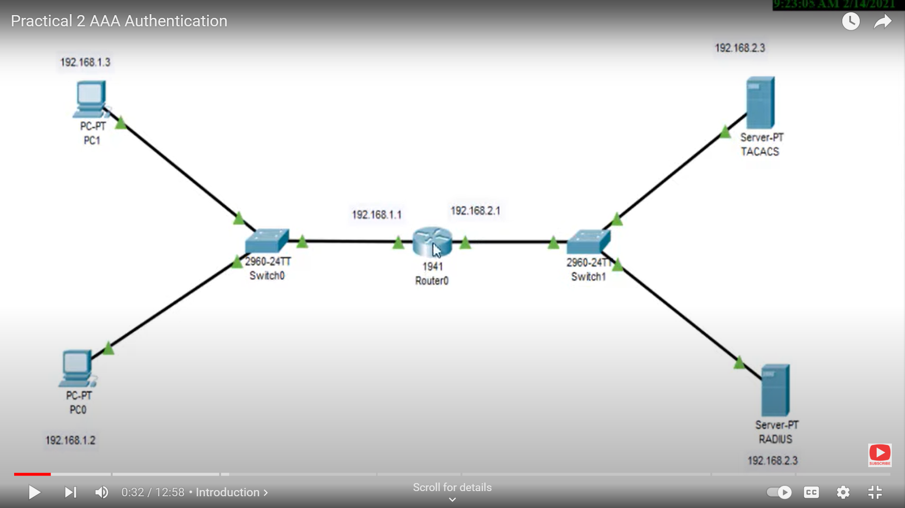

Step 2: Enable the AAA services of TACACS server

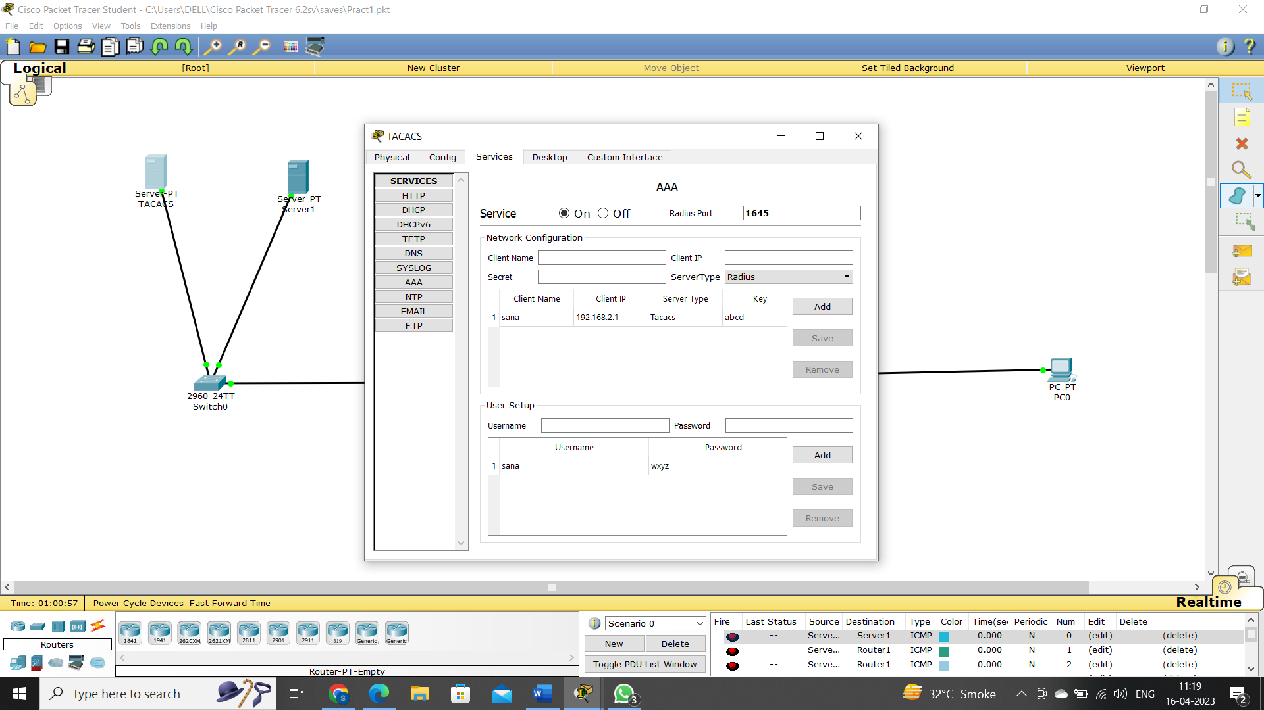

Step 3: Enable the AAA services of RADIUS server

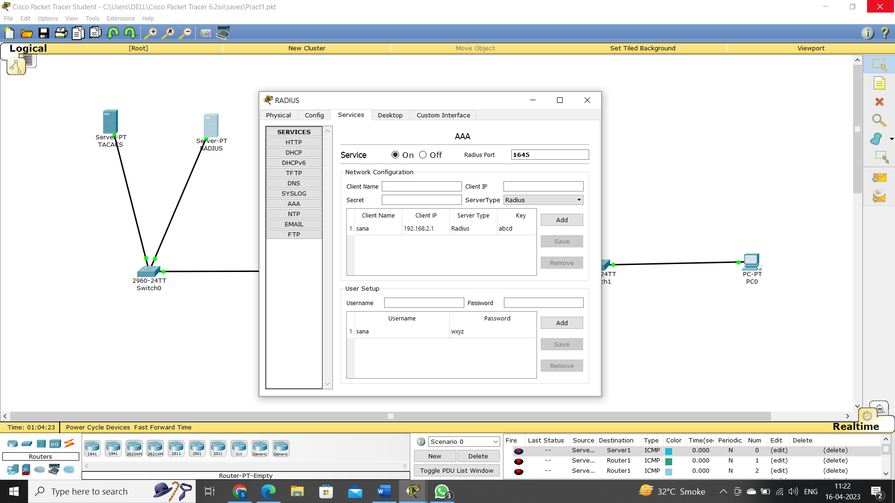

Step 4: Write the following commands in the CLI of router to configure above services

Router > enable

Router # Configure terminal

Router (config) #aaa new-model

Router (config) #tacacs-server host 192.168.2.3 key abcd

Router (config) #radius-server host 192.168.2.2 key abcd

Router (config) #aaa authentication login smile group tacacs+ group radius local

Router (config) #line vty 0 4

Router (config-line) #login authentication sana

Router (config-line) # exit

Router (config) # exit

Step 5: Check AAA authentication from PC`s

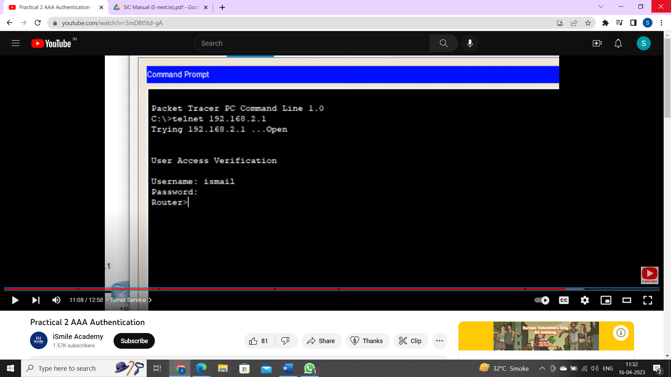

PRACTICAL 3

Aim : Configuring Extended ACLs

Configure, Apply and Verify an Extended Numbered ACL

Step 1: Configure the topology

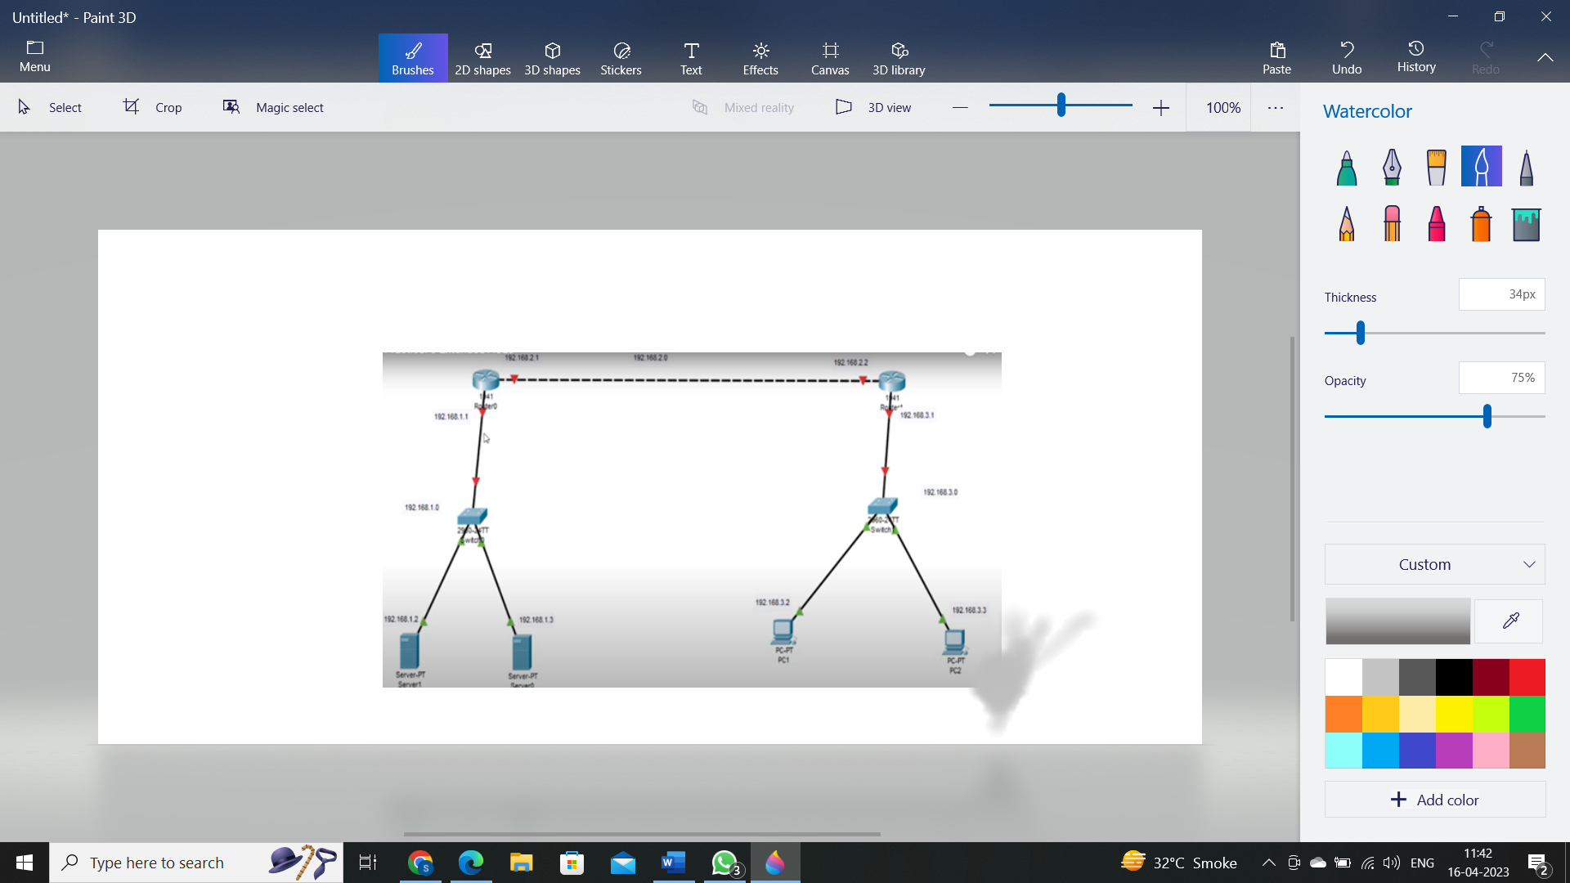

Step 2 : Perform RIP Routing

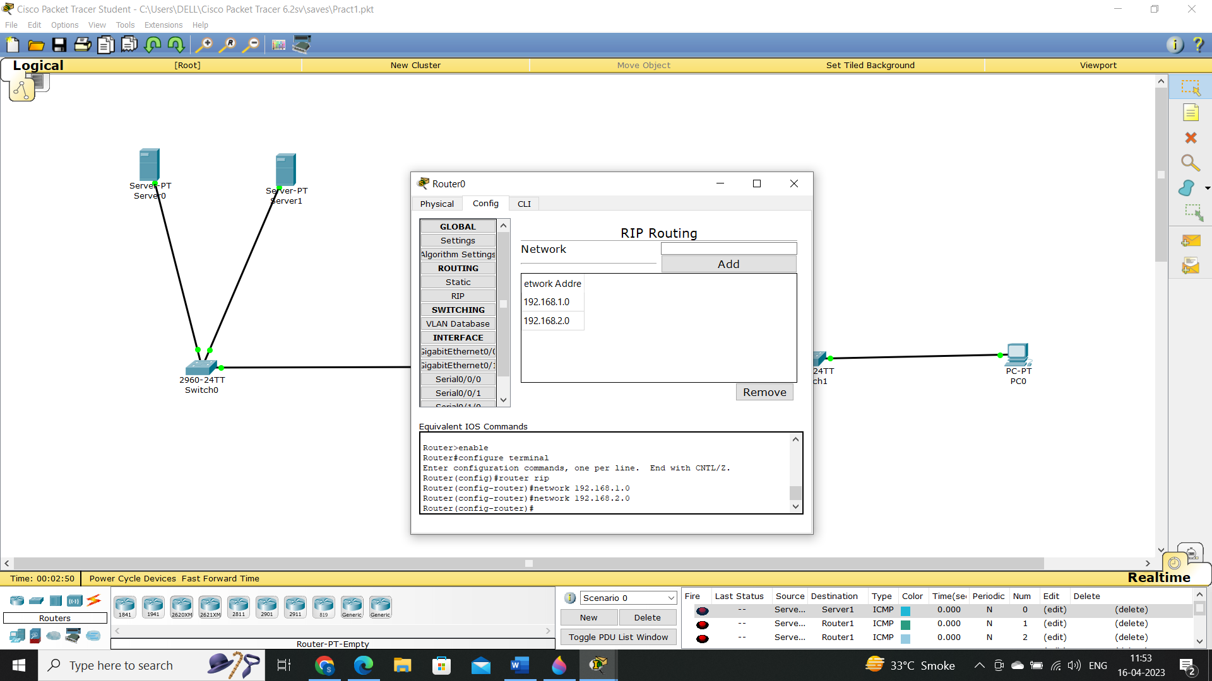

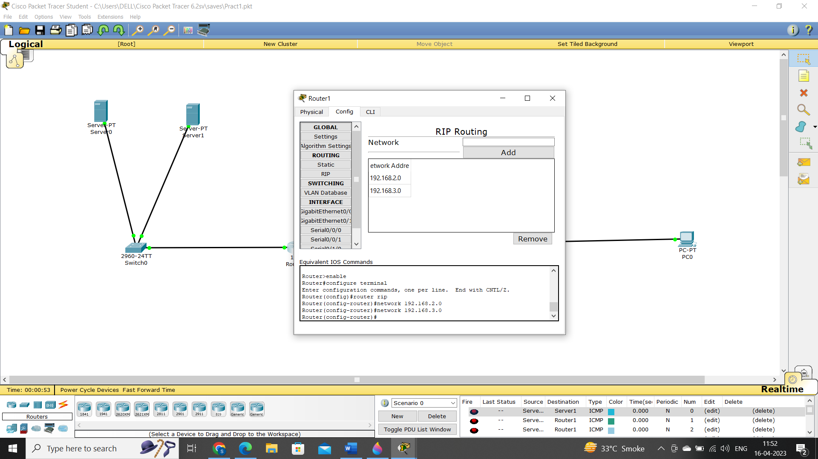

Step 3: Check the connectivity using ping command

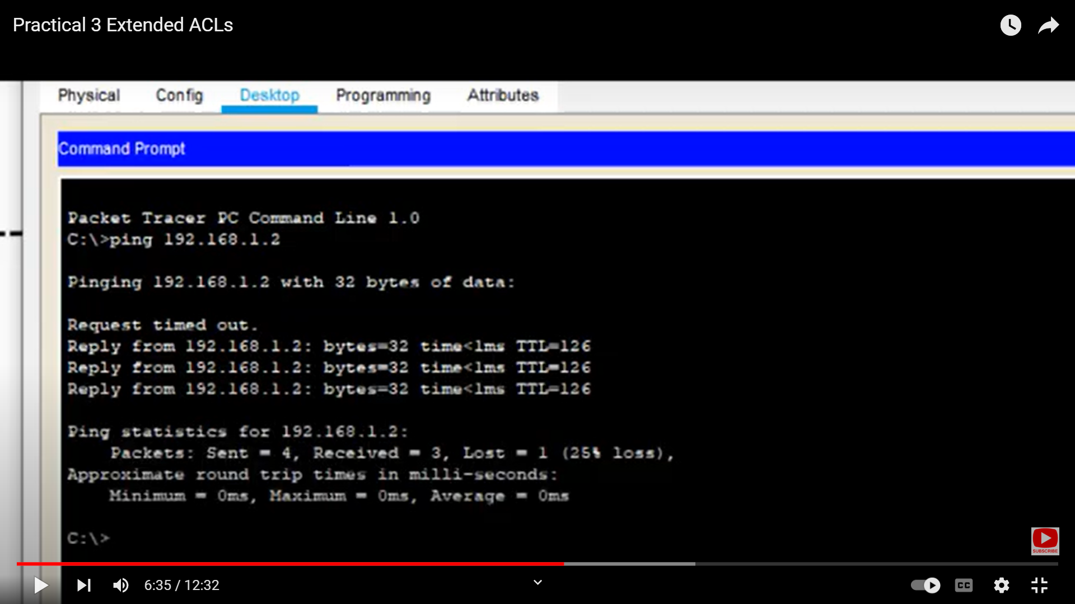

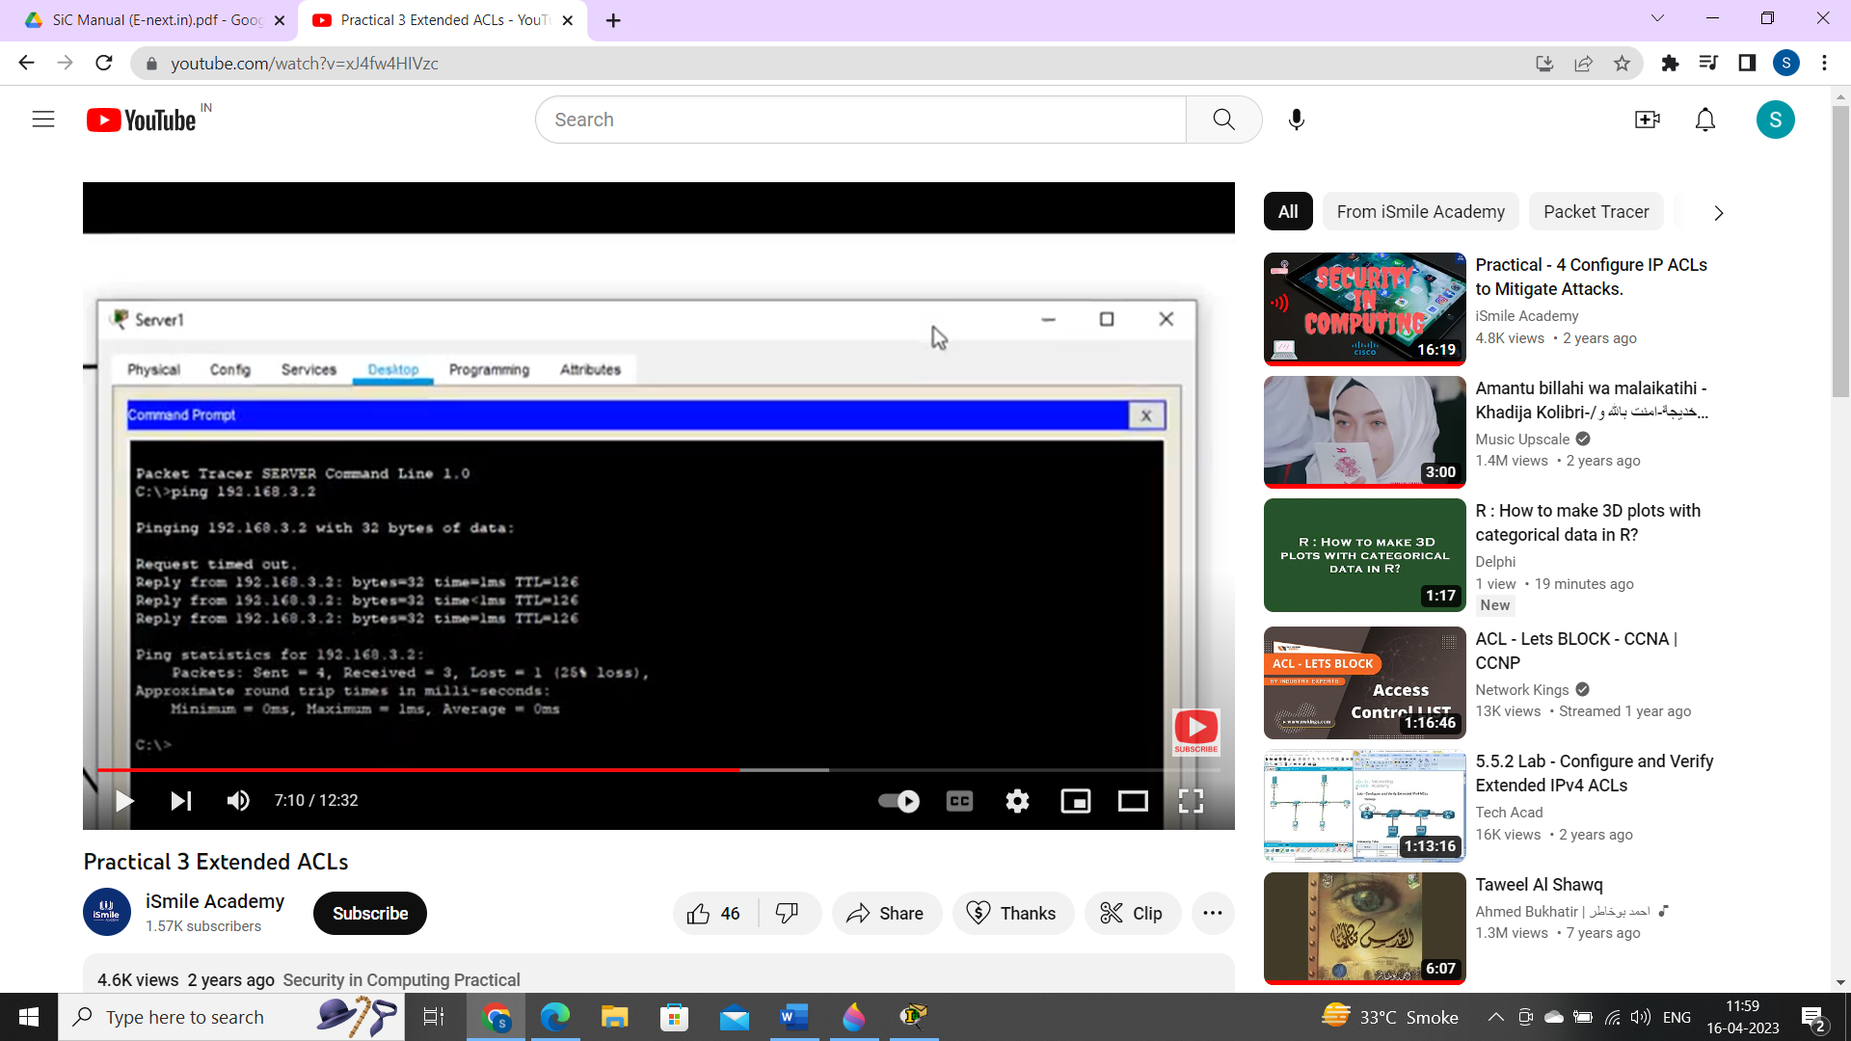

Step 4: Configuring ACL such that PC0 gets services from server but PC1 does not.

Write Following commands in the CLI of Router1.

Router>enable

Router # configure terminal

Router (config) # access-list 100 permit tcp host 192.168.3.2 host 192.168.1.2 eq ftp

Router (config) # interface gigabitEthernet0/0/1

Router (config-if) # ip access-group 100 out

Router (config-if) # exit

Router (config) # exit

Step 5 : Verify

Go to PC0

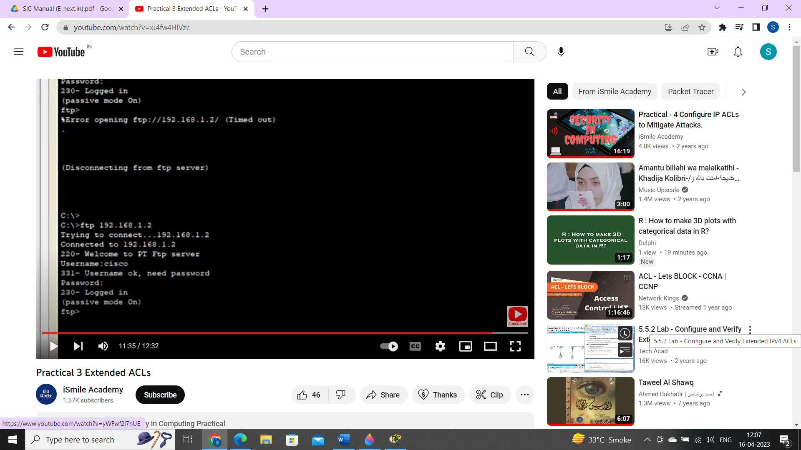

Go to PC1

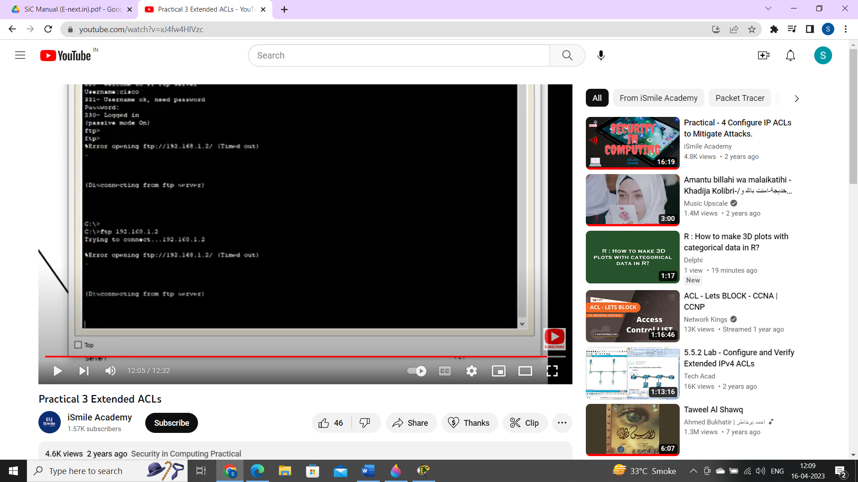

PRACTICAL 4

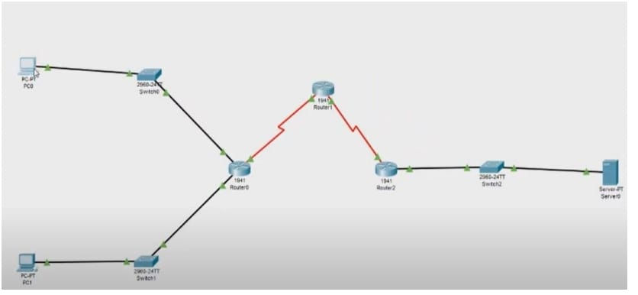

Aim: Configure IP ACLs to mitigate Attacks

An ACL is a group of statements that define whether packets are accepted or rejected coming into an interface or leaving an interface.

(1) ACL statements operate in sequential, logical order (top down).

2) If a condition match is true the pocket, is permitted or denied, and the rest of the ACL statements are not checked.

3) If all the ACL statements are unmatched, an implicit "deny any statement is placed at the end of the list by default.

Extended IP ACLs can filter on:

[1] Source IP address.

[2] Destination IP address.

[3) Protocol (TCP, UDP)

4) Port Numbers (Telnet - 23, http-80 etc) and other parameters.

Step 3: perform RIP routing for all the routers

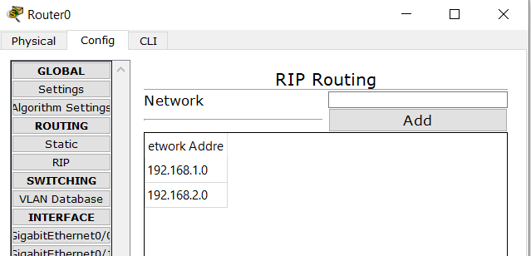 router 0

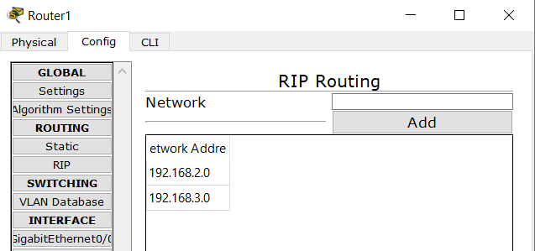 router 1

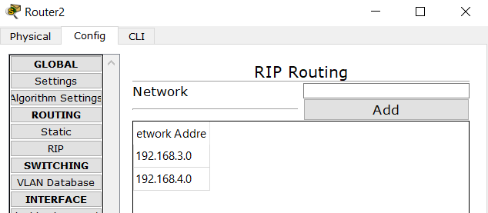router 2

Step 4: write following commands in the CLI of the all routers.

Router> enable

Router# configure terminal

Router (config)# ip domain-name sips.com

Router (config)# hostname Ro

Ro (config)# crypto key gonerate rsa

How many bits in the modulus [512]: 512

Ro (config) # line vty 0 4

Ro (config-line) # transport input ssh

Ro (config-line) # login local

Ro (config-line) # exit

Ro (config) #username admin privilege 15 password tyit

Ro (config) #exit

Step 5: Configuring ACL such that only pc can access routers and server cannot access them.

Writer following commands in the CLI of all the routers:

R0#configure terminal

R0(config)#access-list 10 permit host 192.168.4.2

Ro (config) #line vty 0 4

Ro (config-line) # access-class 10 in

R0(config-line)#exit

Step 6: verify

In command prompt of PC1

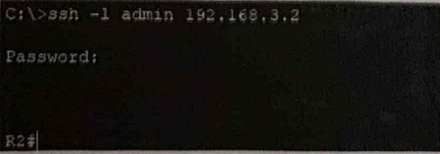

In command prompt of server 1 type ssh –l admin 192.168.3.2

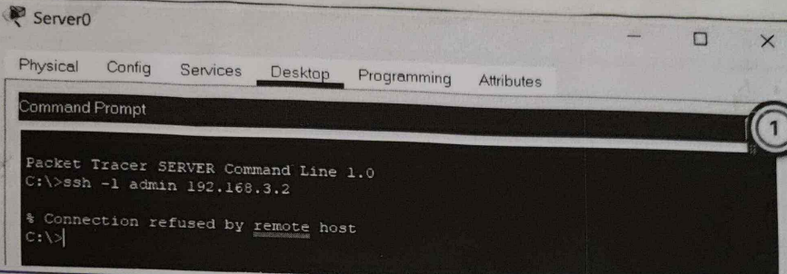

PRACTICAL 5

Aim: Configure IPv6 ACLs

Step 1: Add serial interface to all the routers

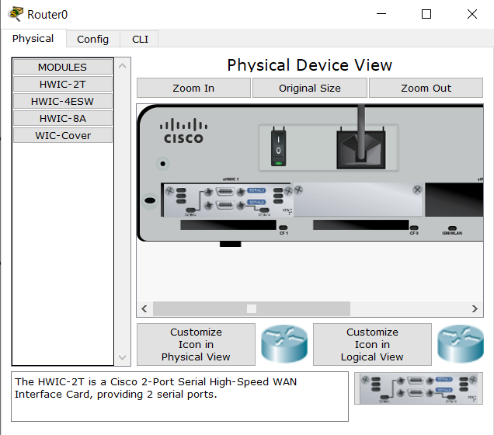

Step 2: Configure the Topology



IP Configuration

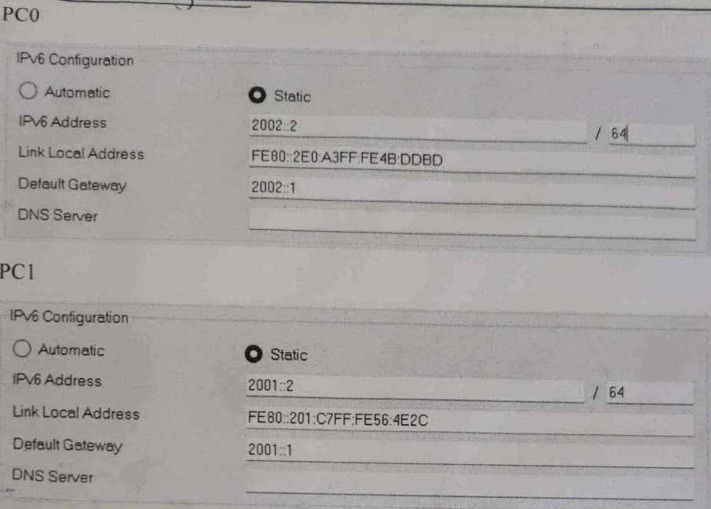

IPv6 configurations for routers.

In the CLI of Routar0

Router>enable

Router # configure terminal

Router (config)# ipv6 unicost-routing

Router (config)# interface gigabitEthernet 0/0

Router (config-if)# ipv6 address 2001: 1/64

Router(config-if)# ipv6 rip a enable

Router (config-if)# no shutdown

Router (config-if)# exit

Router (config)# interface gigabit Ethernet 0/1

Router (config-if)# ipv6 address. 20021/64

Router (config-if)# ipv6 rip a enable

Router (config-if)# no shut down

Router(config)#interface serial 0/1/0

Router(config)#ipv6 address 2003::1/64

Router(config-if)ipv6 rip a enable

Router(config-if)no shutdown

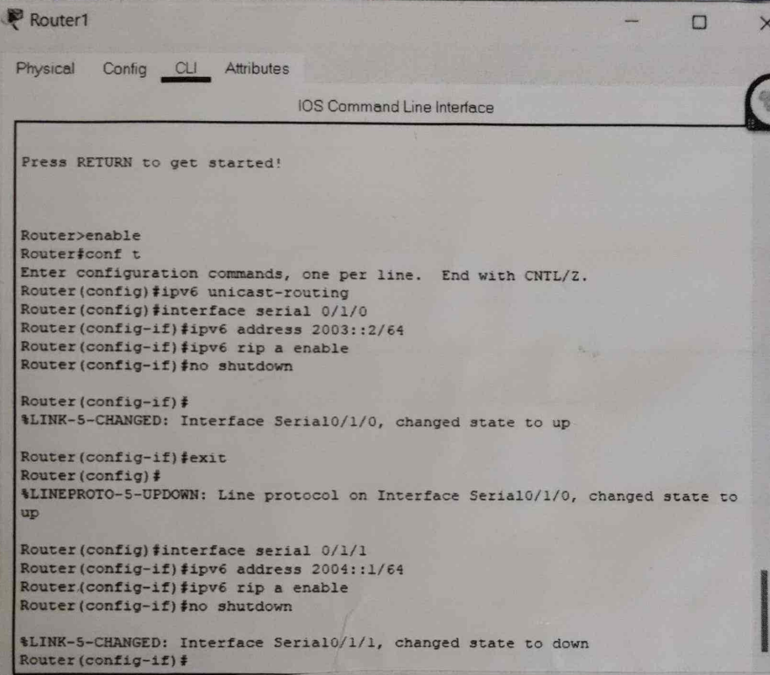

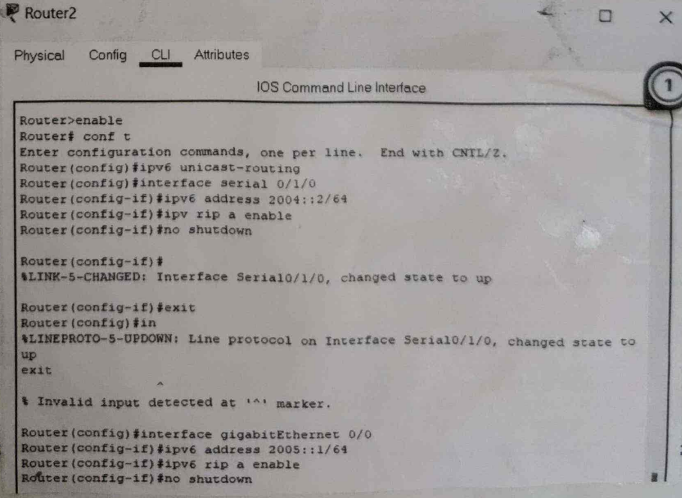

Step 3: Check the connectivity using ping command

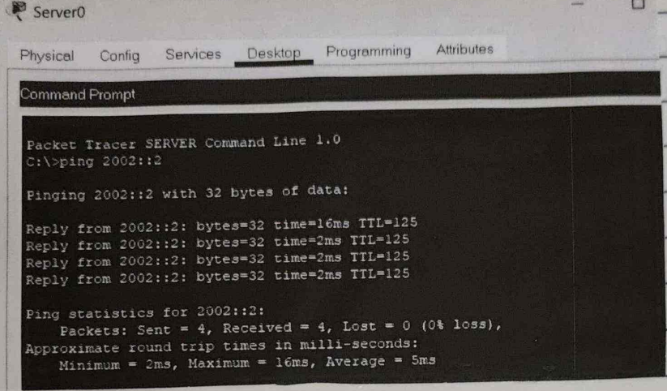

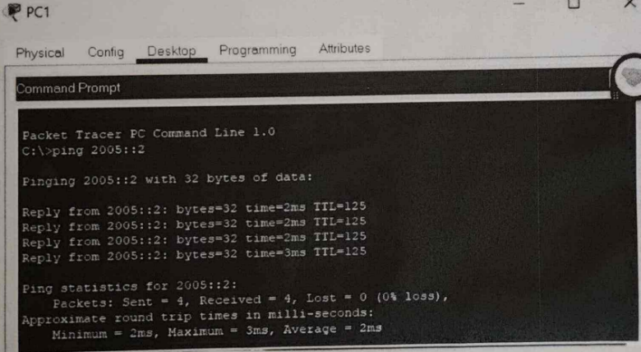

Step 4: Check from pc if you can access web services of server using web browser of pc

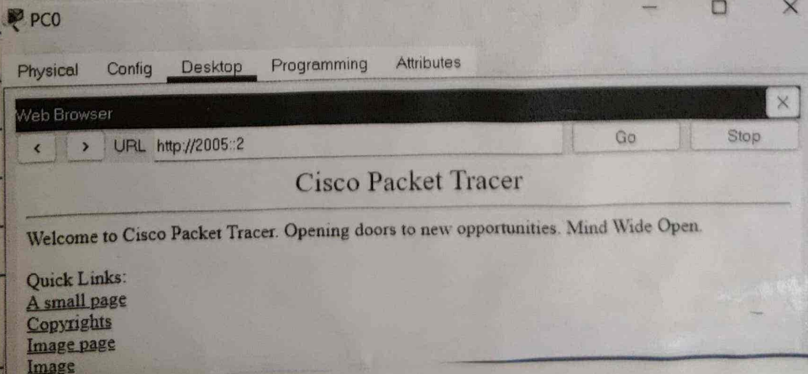

Step 5 :- Now we will set ACL such that no host can these services from server. We Configure the ACL and apply it to Router1 with the following conditions:

1) No HTTP or HTTPS allowed on server by any host

2) No www services accessible on the server by host.

3) Only ipv6 packets allowed towards the server.

In the CLI of Router1:-

Router> enable

Router # configure terminal.

Router (config)# ipv6 access-list abc

Routor (config-ipv6-acl) # deny tcp any host 2005::2 www

Router (config-ipv6-acl) # deny tcp any host. 2005:12 443

Router (config-ipv6-acl) # permit ipv6 any any

Router (config-ipv6-ac1) # exit

Router (config)# interface serial 0/1/1

Router (config-if)# ipv6 traffic-filter abc out

Router (config-if)# exit

Step 6: verify

